2 Planes for Sale

I have the following 2 planes for sale;

**Fokker D.VII (£100)**

This is a Super Flying Models version of the Fokker D.VII. It is a 1.2m (48in) wingspan; balsa and Lite Ply build; covered in Oracover. The aircraft comes fitted with servos, ESC and motor and all that is required for flight is a Receiver and 4S LiPo. The aircraft has been flown once and I can report that it is a pussy cat to fly. Probably best flown on light wind/calm days.

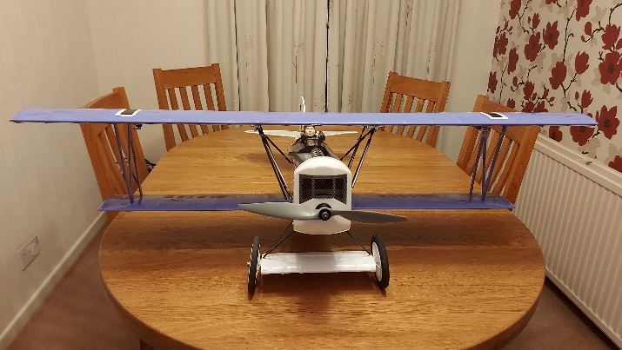 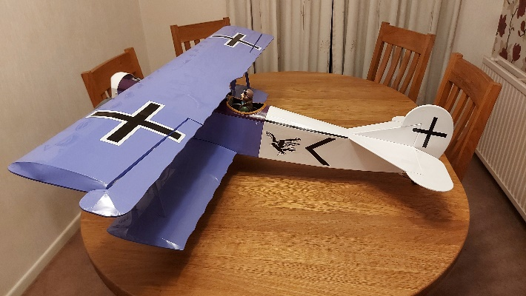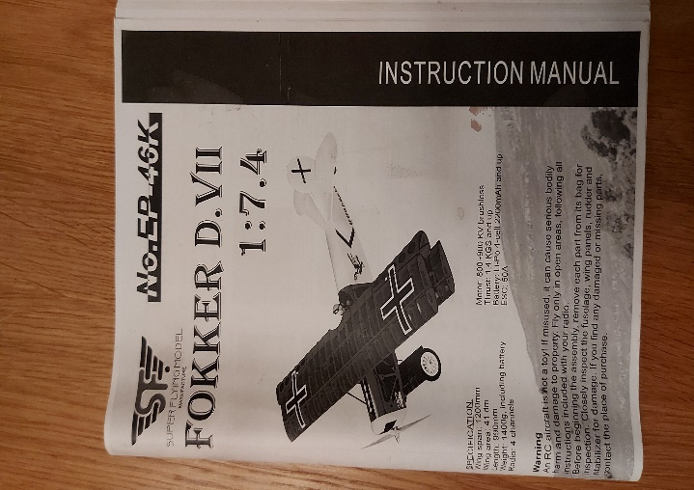

**Messerschmitt BF-109 (£50)**

This is a Dynam 1.27m (50in) wingspan, foam model of the Messerschmitt BF-109 The aircraft comes fitted with servos, ESC, motor and retracts all that is required for flight is a Receiver and 4S LiPo. The aircraft has been flown many times but has become a hangar queen for the last two seasons so have decided to sell.

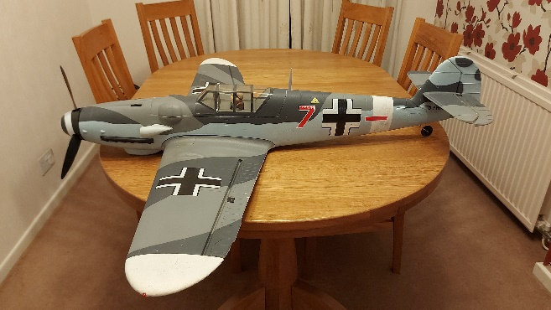 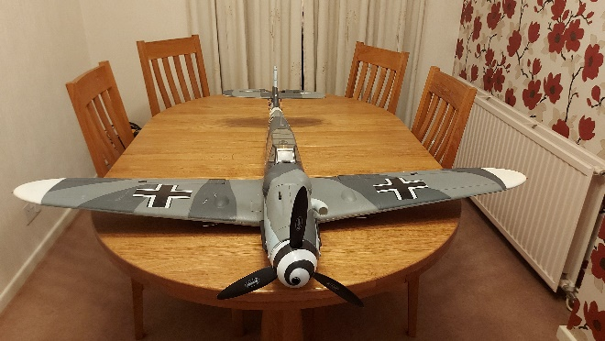

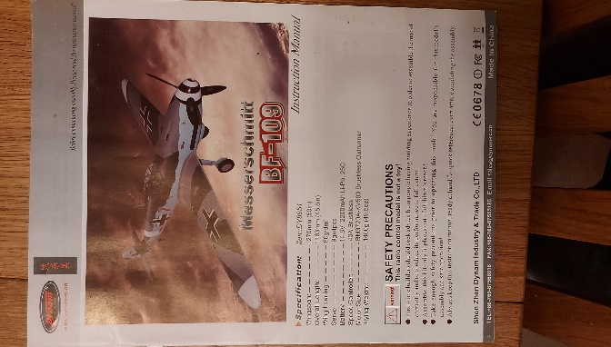

Please contact John Murdy :

johnmurdy51@gmail.com

07982 231462