Due to my age and slowing reactions I have reviewed my hangar contents and the following models are surplus to my requirements and are for sale. If not sold locally they will go on Ebay.
I will be donating all the proceeds to Trinity Hospice, Blackpool.
Hangar 9 Ultra Stick (80”) ARTF
Includes:
- DLE 30 fitted with after-market exhaust
- 9 servos
- Electronic ignition switch.
I bought it from Steve Webb a couple of years ago. It has had less than a dozen flights and has never crashed. The basic airframe is currently available for £335 + delivery.
Offers over £275
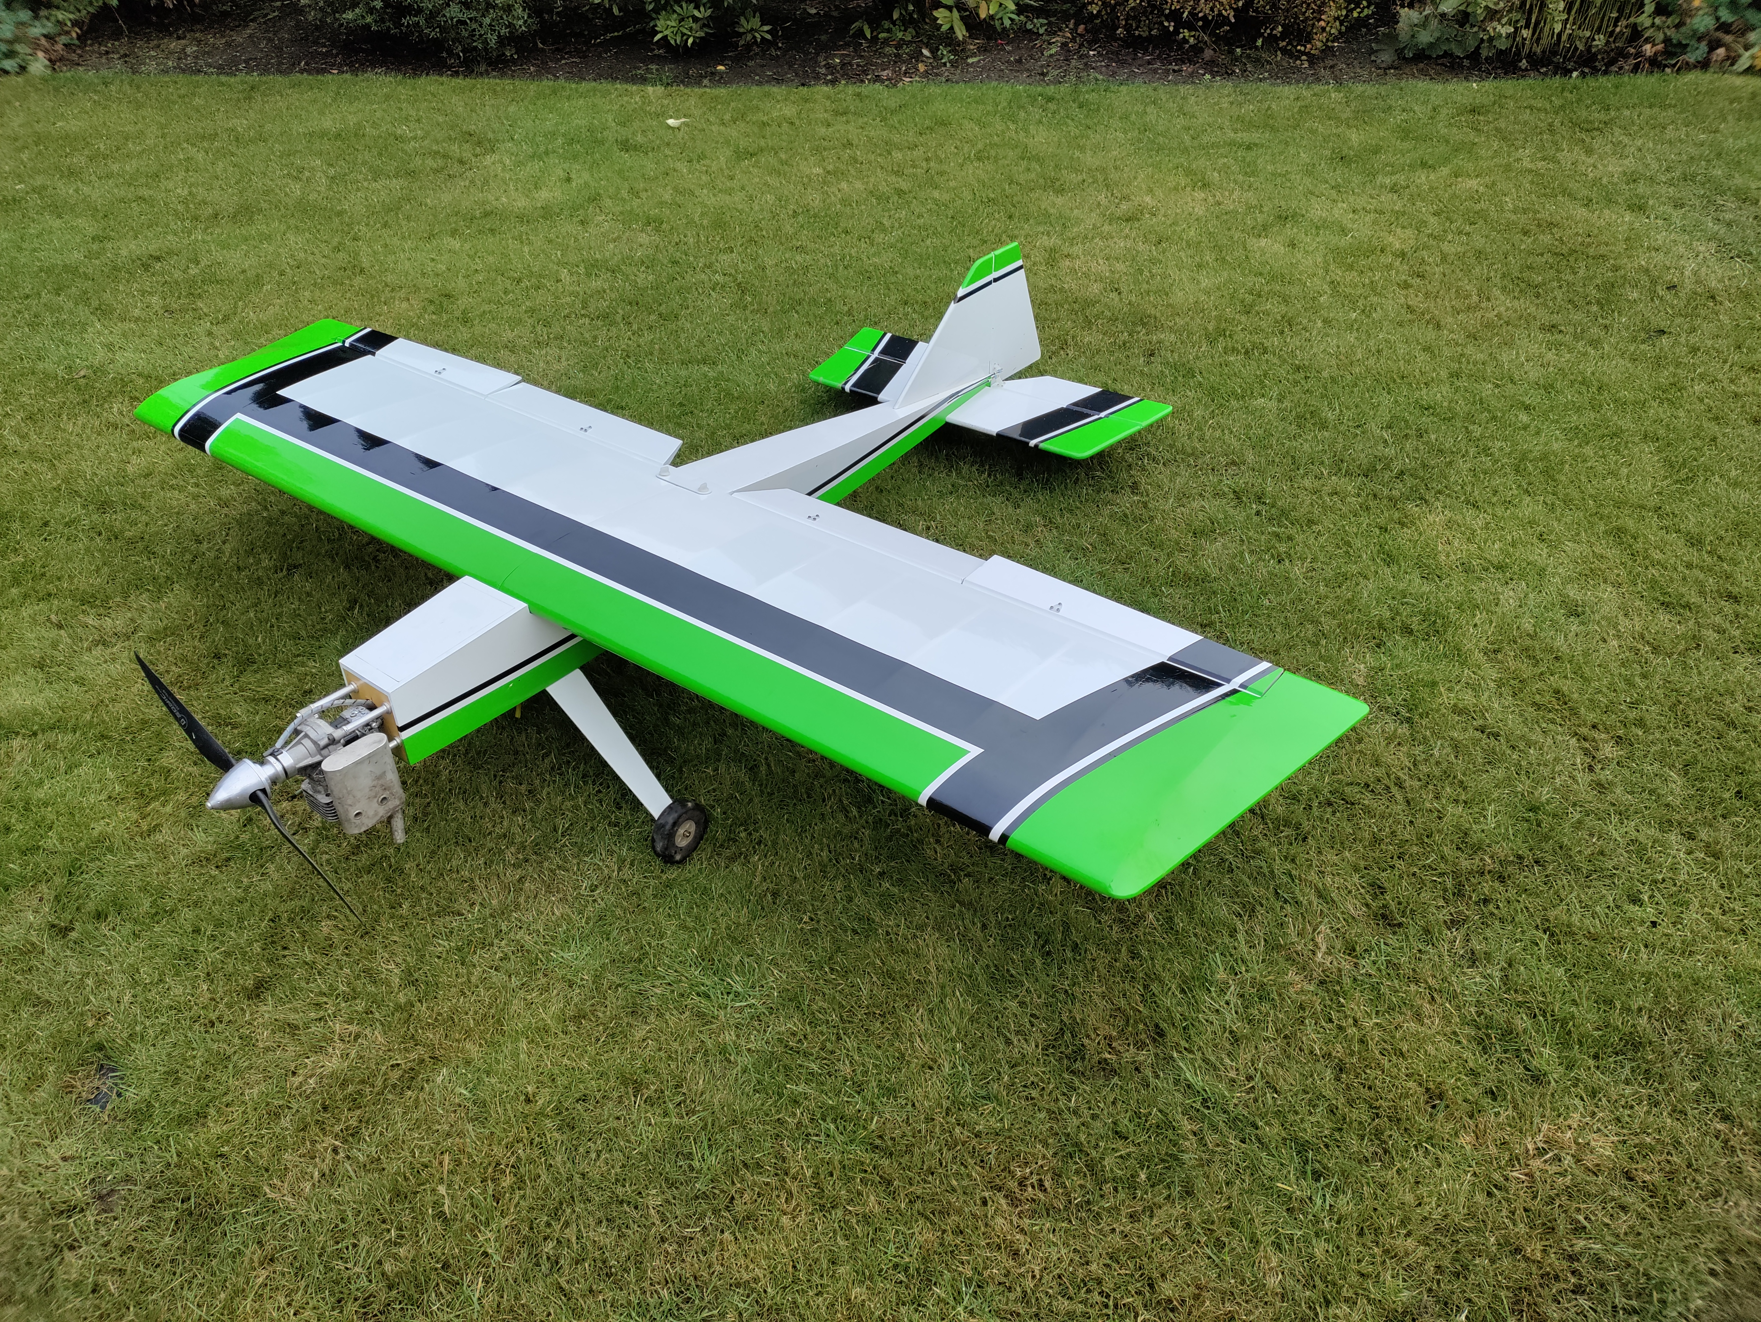
Fournier RF5 (90”)
Built by me to 1:6 scale from the Duncan Hutson plan.
Includes:
- Electric Motor & Prop suitable for a 3S battery
- Electric retracting mono wheel undercarriage
- Over wing hinged airbrakes
- 2 piece wing with carbon joiner
- All servos
Offer – no reserve

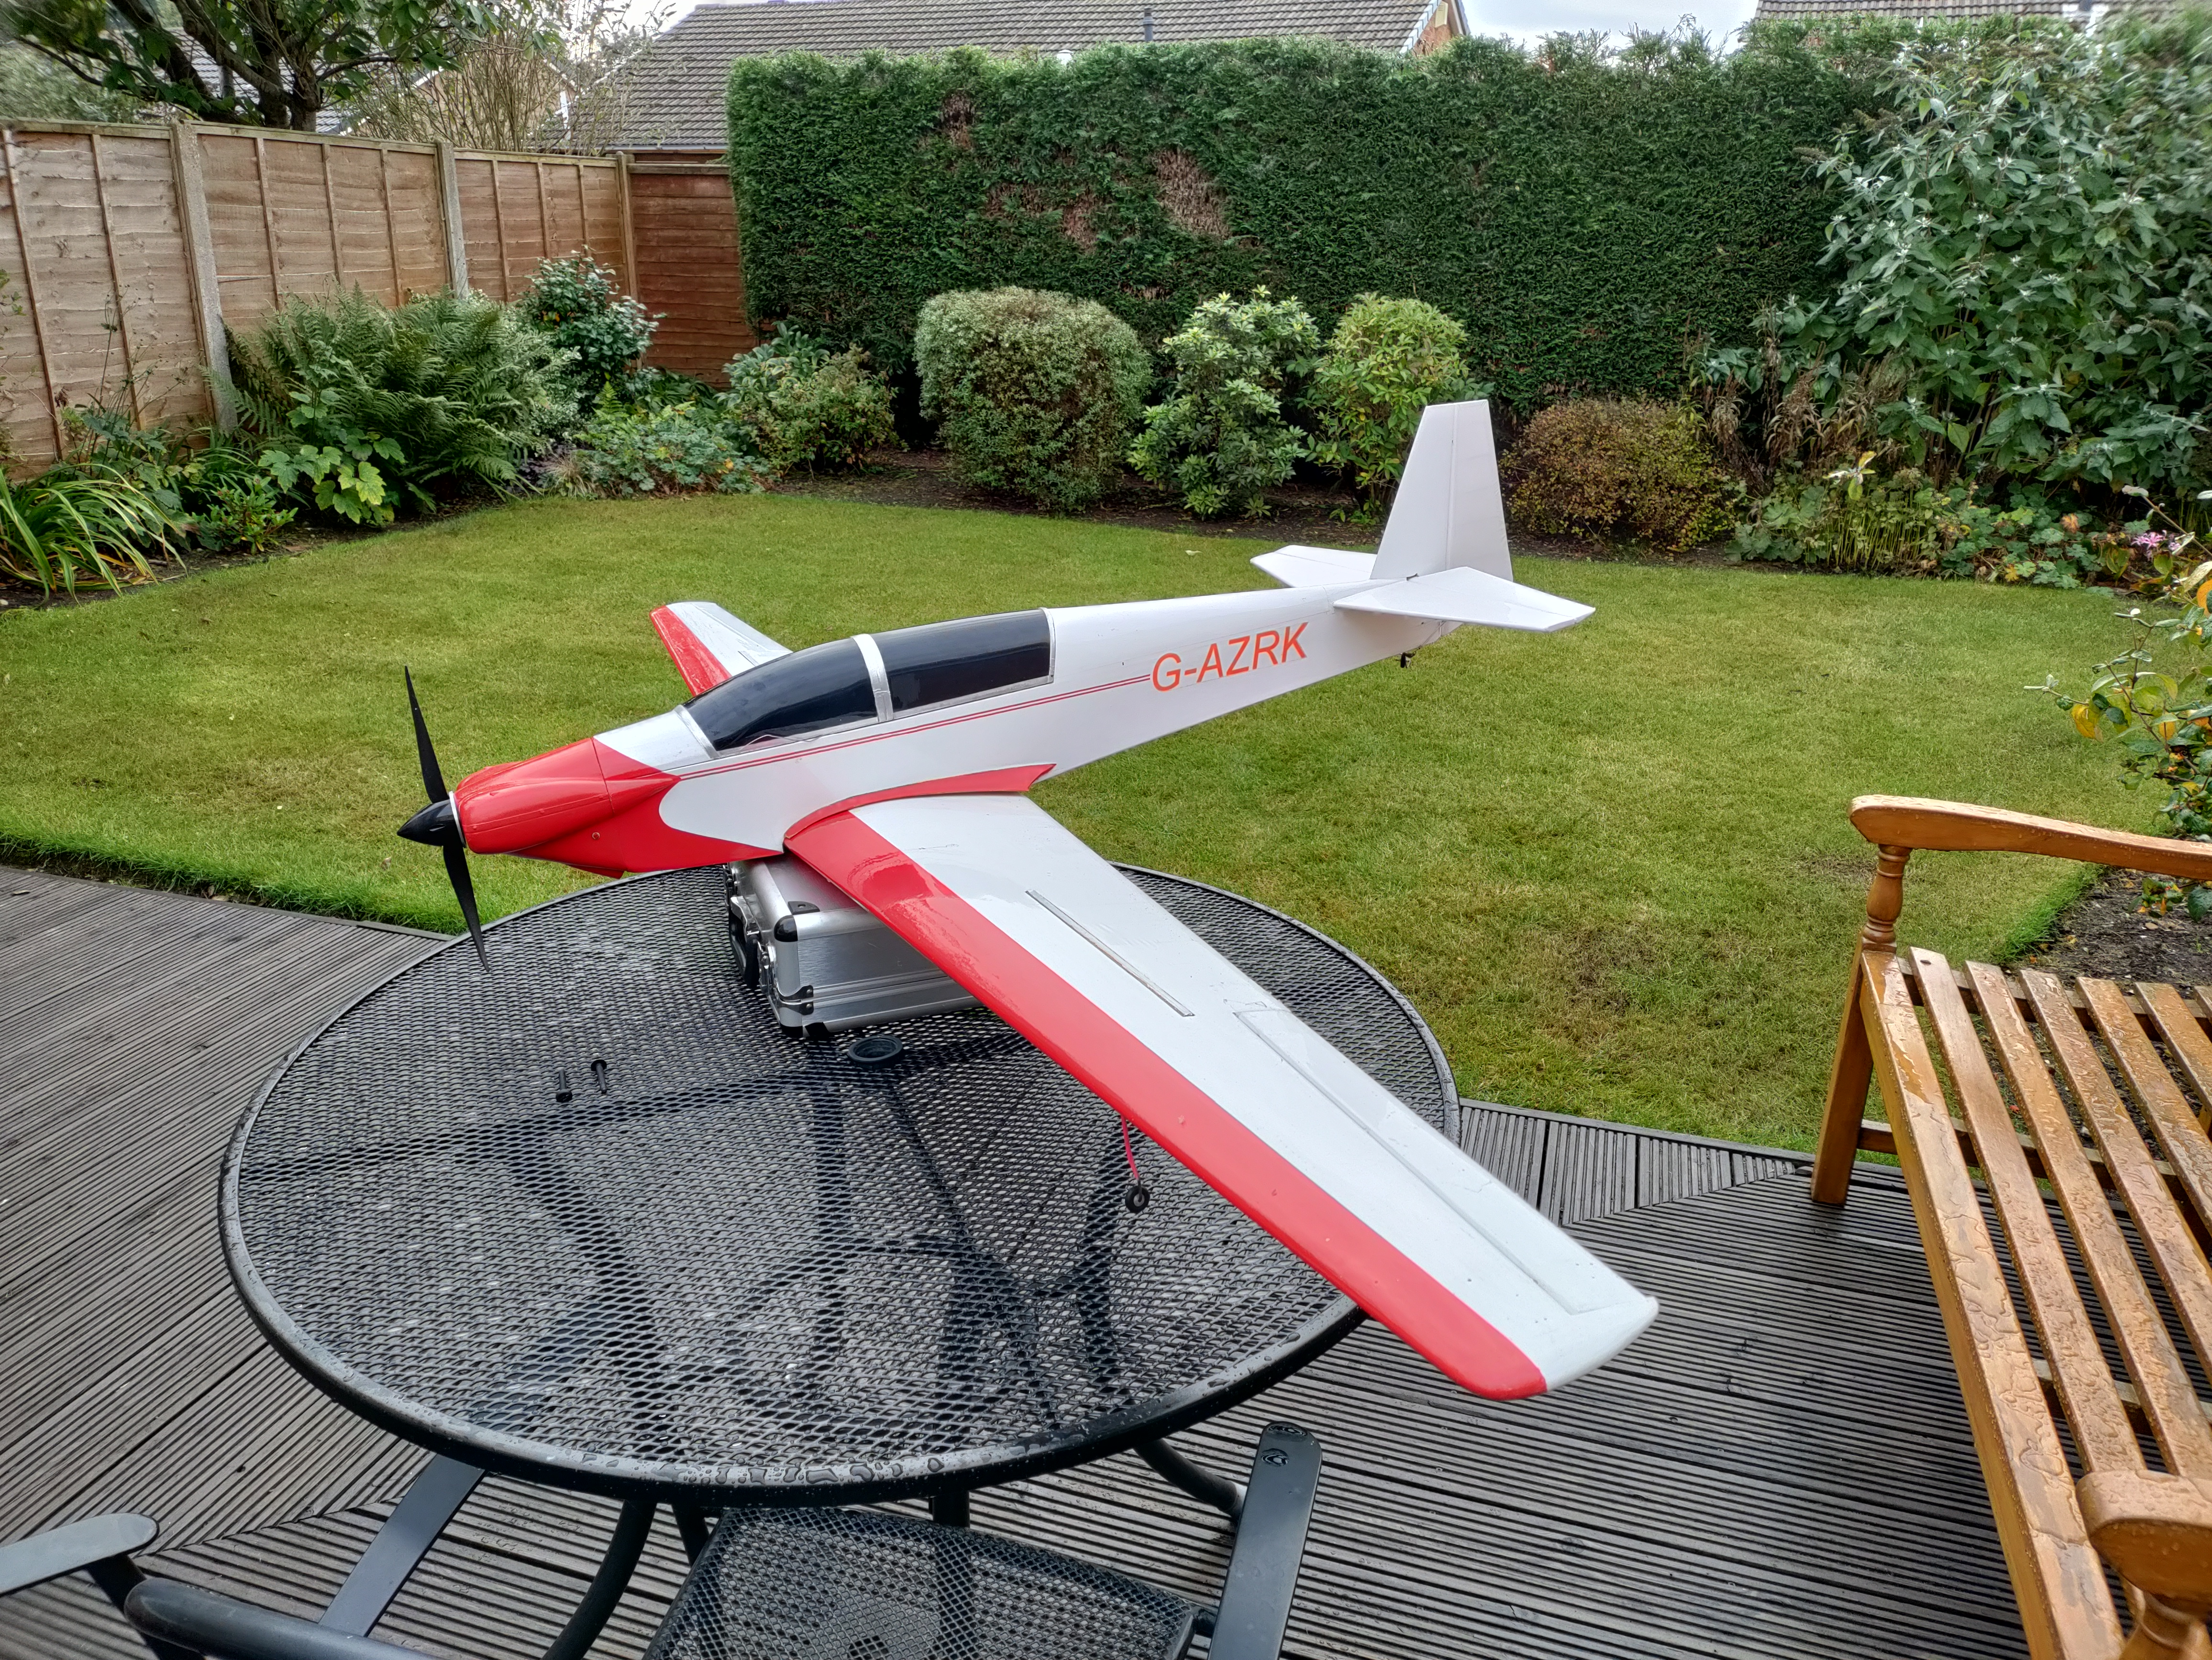

Discuss Glider (2,7m)
ARTF complete with servos.
Just a donation
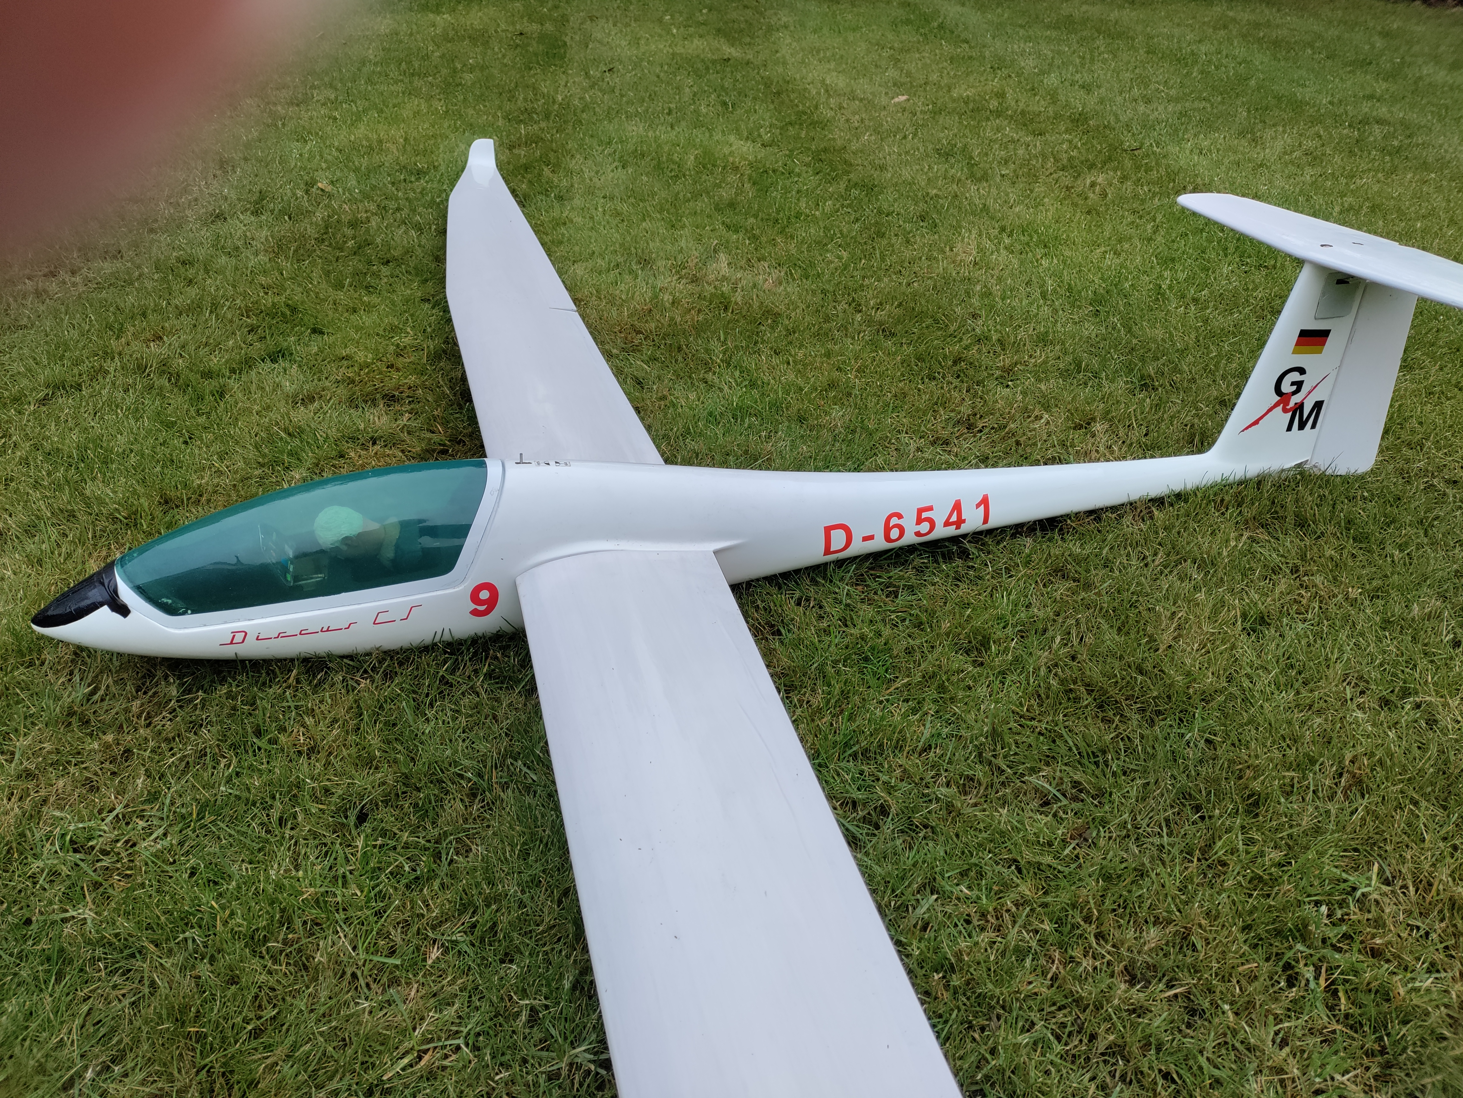

Contact - Keith Dobson
mobile - 07733996078
e-mail - keith@kdobson.plus.com

